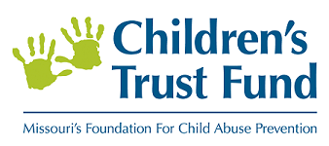
Child Abuse and Neglect Prevention
Capacity Building Grants Initiative

The Missouri Children’s Trust Fund (CTF) Board of Directors is pleased to announce the availability of funding designed to increase providers’ capacity to prevent child abuse and neglect by improving:

- Collaboration through Collective Impact
- Operational capacity
- Financial management
- Board leadership
- Strategic planning
- Program development
- Resource development
- Community engagement

CTF will make available $240,000 in Fiscal Year 2020 (January 1 – June 30, 2020) designed to support eligible agencies/organizations in building their capacity to prevent child abuse and neglect. Projects proposing to build capacity in their community/region through Collective Impact will receive favorable consideration; however, organizations proposing non-collective impact capacity building efforts are also encouraged to apply. Funding is available to support up to two additional years for applicable projects.
CTF will accept Letters of Intent (LOI) to apply through October 1, 2019. The LOI template is available at https://ctf4kids.org/program-partners/ctf-funding-opportunities/ and is included as Attachment 3. Full applications will be solicited by invitation only. Invitations to submit a full application will follow the review of Letters of Intent.

BACKGROUND
The Children’s Trust Fund (CTF) is Missouri’s foundation for child abuse prevention. CTF was created by the Missouri General Assembly in 1983 as a 501(c)(3) non-profit organization whose sole purpose is to prevent the abuse and neglect of children. Located within the Missouri Office of Administration, CTF is governed by a seventeen member Board of Directors.
Our Vision – Strong Families, Safe Kids
The Missouri Children’s Trust Fund envisions children and families in a safe, nurturing and healthy environment, free from child abuse and neglect.

Potential applicants are encouraged to read the entire application before submitting a LOI to ensure understanding of expectations.

Focus: Building community and organizational capacity to prevent child abuse and neglect.

Letter of Intent (LOI) Deadline: Potential applicants must submit a Letter of Intent by Tuesday, October 1, 2019. Invitations to submit full applications will sent by Tuesday, October 15, 2019

Full Application Deadline: Applications (by invitation only) are due Friday, November 15, 2019

Grant Range: $5,000 - $50,000 for the first 6-month contract period, and $10,000 to $100,000 for each renewal year (two renewal years maximum)

Contract period: Initial contract period is January 1, 2020—June 30, 2020, with two additional twelve-month extensions available depending on project

Eligibility: 501(c)(3) nonprofit organizations or public agencies that have provided services in the state of Missouri for more than one year, with no overdue reports to or compliance issues with CTF

Requirements: Participate in evaluation process as determined by CTF

ELIGIBILITY
CTF is authorized to award grants to schools, public agencies and private, non-profit organizations (must submit verification of 501 (c)(3) status). Applicants must have provided services in the state of Missouri for more than one year, and have no overdue reports to or compliance issues with CTF.

CTF Capacity Building Prevention funds cannot be used to match federal Community Based Child Abuse Prevention (CBCAP) funds.

CTF FUNDING CRITERIA FOR ORGANIZATIONAL CAPACITY BUILDING GRANTS
Definition | Criteria for Consideration | Eligible Activities
Internally-focused efforts designed to help an organization fulfill its mission and improve its effectiveness by building capacity to enhance:  - Collaboration through Collective Impact*  - Operational Capacity  - Financial Management  - Board Leadership  - Strategic Planning  - Program Development  - Resource Development  - Community Engagement | Degree to which the applicant’s mission, vision and goals align with CTF’s mission and strategic direction in preventing child abuse and neglect  Reasonableness and feasibility of request  Characterization of the current strengths of the applicant organization and the gap that capacity building will fill  The potential for success of the capacity building methodology given the current state of the applicant organization  Applicant’s connection to partners and other stakeholders in their community  Potential impact of proposed project – what will be different due to improved capacity? | Internally-focused activities that build capacity in one or more areas such as:  - Network and collaboration building rooted in Collective Impact  - Strengthening operations capabilities, including leadership and line-staff development and policies and procedures development  - Strengthening financial management capabilities  - Enhanced governance/board development  - Creation of an organizational roadmap to accomplish its mission  - Attainment of tactical skill to enhance existing or develop new programming  - Improved evaluation, data and measurement  - Strengthening resource development skills  - Enhanced community engagement capabilities through collaboration, advocacy, public education and awareness

*COLLECTIVE IMPACT
CTF is very interested in capacity building initiatives that work to enhance the effectiveness and quality of services through Collective Impact. Defined as “the commitment of a group of important actors from different sectors to a common agenda for a specific social problem at scale”, Collective Impact efforts have the potential to enhance services and data collection, reduce duplication and progress a shared mission (https://ctb.ku.edu/en/table-of-contents/overview/models-for-community-health-and-development/collective-impact/main). Of importance, collective impact initiatives involve multiple agencies working toward a common goal and typically involve a “backbone” agency that coordinates this effort.

Successful Collective Impact initiatives have been shown to have five conditions in place that promote true alignment of the group and produces results greater than can be achieved through services provided in isolation (https://ssir.org/articles/entry/collective_impact). The following visual highlights the five conditions of Collective Impact. More in-depth information can be found at the links already provided and through the Collective Impact forum (https://www.collectiveimpactforum.org/).
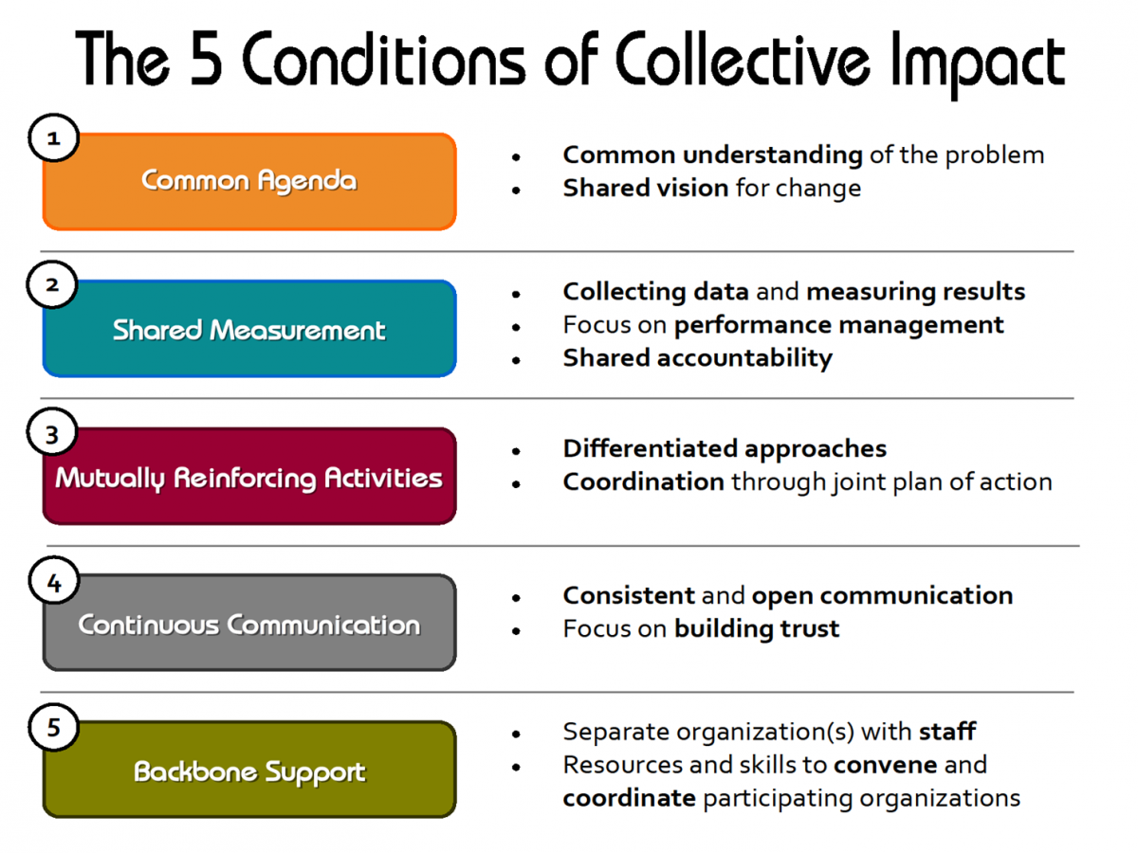 Credit: United Way of Northern California (https://www.norcalunitedway.org/collective-impact)
___________________________________________________________________________________________

GRANT RANGE
CTF anticipates funding proposals ranging from $5,000 - $50,000 for the first six months of the project, beginning January 1, 2020 and ending June 30, 2020.

Applicants may apply for two 12-month contract extensions, ranging from $10,000 - $100,000, for a maximum thirty-month (2.5 years) project. Contract extensions are contingent upon on-going progress and compliance.

GRANT REQUIREMENTS
Background Checks
All employees and volunteers having direct contact, care/treatment or custodial responsibility with/for children younger than eighteen years in age are required to have criminal background checks prior to employment. Other CTF funded employees who may not have direct contact with families must also have background checks. Minimum requirements for CTF grantees:

- Grantee personnel must register with and undergo child abuse/neglect and criminal background screenings prior to providing services, using the Family Safety Care Registry (FCSR). Thereafter, FCSR screenings must be completed annually. Refer to www.health.mo.gov/safety/fcsr/about.php for FCSR information.

- In addition to the FCSR, a criminal background check must be conducted upon hire that includes completing and submitting two (2) sets of fingerprints, one to the Missouri State Highway Patrol (MSHP) and one to the national Federal Bureau of Investigation (FBI). Grantee agencies will need to register their agency with the Missouri Volunteer and Employee Criminal History Services (MOVECHS) by following the instructions posted at: https://mshp.dps.missouri.gov/MSHPWeb/PatrolDivisions/CRID/MoVECHSProgram.html. Once registered through MOVECHS, agencies will access the Missouri Automated Criminal History System (MACHS) at: https://www.machs.mshp.dps.mo.gov/MACHSFP/home.html and follow the instructions posted there to obtain both an MSHP and a national FBI criminal record check by registering with the Fingerprint Portal.

Monitoring/Site Visits, Program Reporting and Evaluation
All grantees will consent to monitoring and reporting requirements as established by CTF. This includes on-site reviews to ensure financial/programmatic compliance and annual reporting. All successful applicants will be required to participate in an evaluation process as determined by CTF and an external evaluator.

Contracting/Grant Funding
Successful applicants are required to attend a compliance meeting to be held in Jefferson City. Applicants may include estimated travel costs for the meeting as part of the project budget (currently, the state mileage rate is capped at 43 cents per mile).

Only expenses incurred during the contract period will be reimbursable. Funds will not be available to grantees without a signed, fully executed contract. Contracts must be signed and returned to CTF by the date noted in the award letter. Funds are paid on a reimbursement basis.

Programs will invoice for contract-related expenses on the CTF program invoice form. Invoices are due by the fifteenth (or next working day if on a weekend) of the month following the month in which expenses are incurred.

Successful applicants must be registered vendors through Missouri BUYS (https://missouribuys.mo.gov/) and must participate in E-Verify (https://www.e-verify.gov/), have no taxes due to the State of Missouri and must be in good standing with the federal government.

DEADLINE
Letter of Intent (LOI) - The deadline to submit the LOI to apply is close of business on Tuesday, October 1, 2019. Invitations to submit full applications will be sent by Tuesday, October 15, 2019.

Full Application - For organizations invited to submit a full application, the application submission deadline is close of business on Friday, November 15, 2019. Applications must be emailed to laura.malzner@oa.mo.gov.

REVIEW PROCESS

An evaluation committee will review the LOIs and make recommendations to the CTF Board of Director’s Program Committee. The Program Committee will decide which organizations shall receive an invitation to submit a full application. The same evaluation committee will review and score all full applications for funding. Based on the review, the Program Committee will formulate final recommendations and the CTF Board of Directors will make all final funding decisions.

Applications will be scored using a 100-point metric. Weighted elements of the application include the Narrative sections. Specific scores are noted in the application instructions.

CTF CONTACT
For questions regarding this grant opportunity, please contact Program Director Laura K. Malzner at laura.malzner@oa.mo.gov or 573-751-6511/5147.

APPLICATION INSTRUCTIONS
Complete applications from invited organizations must include responses to all Narrative questions along with a budget for Year 1 and, if applicable, Year 2 and Year 3 (see attachment 1). The application must also include all other documents noted below.

NARRATIVE SECTIONS
Applicants are required to respond to the following sections. Section responses should be complete and include all elements requested. Applicants should also use examples and data when available. Responses should be single-spaced with a font of no smaller than 11, and adhere to the noted page maximums.

- Summary (1/2 page) – 5 points
Provide a brief, but concise, summary of the project.

- Community or Population to be Served (3/4 page) – 10 points
Describe the geographic (include counties and zip codes) and demographic make-up of the population served by the applicant.

Describe the risk of child abuse and/or neglect within the target population/community. Are there high rates of child maltreatment, poverty or infant mortality in the target population/community?

Describe racial disparities that exist within the targeted population/demographic.

- Organizational Mission and Experience (1 page) – 10 points
State the mission of your organization. Describe any experience or accomplishments in the area of child abuse and neglect prevention, including applicant history of providing child abuse and neglect prevention services. State the strengths of your organization and the gap to be filled by capacity building.

- Collaboration within Community (1 page) – 10 points
Describe at least two long-standing effective partnerships with other service providers, including collaborations on current or past projects within the targeted community. Please attach Memorandums of Understanding and/or Letters of Support, or other documentation of long-standing, effective partnerships with at least two other service providers.

- Describe the Proposed Capacity Building Initiative, including the need for the project and the methodology for improving capacity (1.5 pages) – 30 points

- Describe the impact that the applicant hopes will result from the project and how this impact will be sustainable after the grant period (1 page) - 20 points

- Describe the timeline for implementing the requested capacity building project (1/2 page) – 5 points

- Program Budget Description and Justification (1 page) – 10 points
Detail the expenses requested in the budget. Please include the basis for cost and an explanation of why the request is important to the implementation of the project.

REQUIRED DOCUMENTS
Please include the following documents with your application:
- Original Cover Letter and LOI will serve as application cover pages
- IRS 501 (c)(3) certification letter if applicable
- Program Budget (must use CTF budget template – Attachment 1)
- Most recently audited financials (if applicable) or most recently completed financial statement for the organization
- Current year’s operating budget, including income and expenses
- Current list of the organization’s Board of Directors and their affiliations
- Assurances/Certification signature page (attachment 2)

*Narrative questions and required CTF forms (budget) may not be altered. Any applications altering application content will be excluded from consideration.

CHILDREN’S TRUST FUND GRANT APPLICATION Attachment 1
PROJECT BUDGET
This budget sheet is for the proposed project only. Do not provide the total agency budget on this sheet.

SECTION I. - EXPENSES | CTF FUNDS REQUESTED  Year 1 | CTF FUNDS REQUESTED  Year 2 | CTF FUNDS REQUESTED  Year 3
1. Salaries and Wages
(Staff positions)
2. Fringe Benefits
(inclusive of all benefits)
3. Consultant & Contractual Services
(Fees x hours)
- Space Costs
(Example: Rent, utilities & maintenance)
- Consumable Supplies
(Example: Desk Top & paper supplies, postage)
- Travel
(Example: mileage, meals, lodging)
- Communications
(Example: basic & long distance service fees, Cell phone costs)
- Non-consumable Supplies
(Example: desks, computers, etc.)
- Program Related Expenses
(Example: Materials, meeting space, conference registration)
- Other Costs
(Example: Background Check fees)

TOTAL PROGRAM BUDGET (total of 1-10)

BUDGET LINE-ITEM REQUEST MUST CORRESPOND TO SECTION 6 OF NARRATIVE

Attachment 2

CHILDREN’S TRUST FUND
GRANT APPLICATION
ASSURANCE/CERTIFICATION SIGNATURE PAGE

I, the undersigned, certify that the statements in this grant application are true and complete to the best of my knowledge and accept, as to any grant awarded, the obligations to comply with all Children’s Trust Fund requirements specified in the grant award and contract.

I, the undersigned, certify the use of accepted accounting procedures to provide for accurate and timely recording or receipt of fund (by source), expenditures (by items made from such funds) and of unexpended balances. I will establish controls, which are adequate to ensure that expenditures charged to grant activities are for allowable purposes, and that documentation is readily available to verify that such charges/expenses are accurate.

Name:
Authorized Official Title

Signature: ___________________________________________________________________
Authorized Official Date

Attachment 3
Children’s Trust Fund (CTF)
Child Abuse and Neglect Prevention
Capacity Building Application/Letter of Intent (LOI)
Please review the full application before submitting LOI

Organization Name:
Street Address:
City, State, Zip Code:
Telephone Number:
Federal Tax ID#:

Contact Name(s) | Contact Title(s) | Contact Email(s)

Name of Proposed Grant: ______________________________________________________________________

Estimated amount to be requested: Year 1 (January 1 – June 30, 2020) $
Year 2 (July 1, 2020 – June 30, 2021), if applicable $
Year 3 (July 1, 2021 – June 30, 2022), if applicable $

Please respond to the following. Please keep the LOI to no more than three pages, including this page.

- Cover letter from your Executive Director – Please include a cover letter from the applicant organization’s Executive Director detailing why the capacity building funding and project will help the organization take their service and mission to a new level.

- What is the mission of your organization or coalition?

- Briefly describe the community/population and geographic area served by applicant – Include Counties and Zip Codes

- Briefly describe your organization’s experience in child abuse and neglect prevention

- Brief description of Capacity Building project - Please see eligibility criteria in full application.

Submit Letters of Intent to Laura K. Malzner at laura.malzner@oa.mo.gov
Letters of Intent are due no later than October 1, 2019
Invitations to submit a full proposal will follow the review of Letters of Intent

