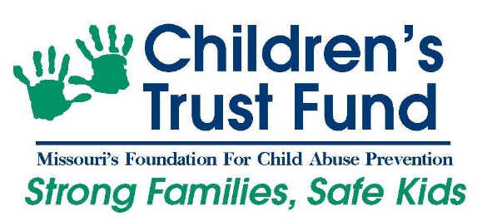
News Release
For Immediate Release: May 2020
Contact: Paula Cunningham
Public Education and Awareness Coordinator
573-751-5147/2266
Paula.Cunningham@oa.mo.gov

Missouri Children’s Trust Fund Awards COVID-19 Relief Funding to Boost Community Prevention Efforts

The Children’s Trust Fund (CTF) Board of Directors recently awarded $155,442 in COVID-19 Relief Funding to fifteen (15) of its current child abuse prevention grantees.

“CTF appreciates the communities who serve our most vulnerable children and is pleased to offer this funding,” said Amy Beecher-McCarthy, CTF Board Chair. “I hope others will reach out and support organizations in their own communities that are working to strengthen families and protect children.”
In recognition that the present COVID-19 pandemic is making it more difficult for child-serving agencies to deliver services to families, especially at a time when the risk for child maltreatment is increasing, CTF disbursed the one-time funding to assist with meeting critical needs. The funding was awarded through an application process for current CTF grantees that focused on priority areas including:
- General operating support
- Concrete supports for families
- Adapting services or providing new services as a result of COVID-19
- Staff time support

This added relief funding is made available from a $260,000 memorial gift that CTF received from the Marigene Smith Brewer Estate in 2018. For a complete list of funded programs, please visit COVID-19 Relief Funding Grants - https://ctf4kids.org/covid-19-relief-funding-grants/.

“CTF knows that in times of stress, rates of child abuse and neglect increase. This means the work of community-based organizations that support vulnerable families is more critical now than ever,” said Emily van Schenkhof, CTF Executive Director. “We believe these grants will assist our partners in meeting the tremendous need in Missouri communities.”

In addition to the relief funding, CTF allowed grantees to:
- Bill for services that could reasonably shift from being in-person to virtual or via telephone, including virtual home visits or online parent classes
- Amend approved budgets to shift funding to meet current need
- Carry over unspent funds into Fiscal Year 2021

“The generous $260,000 bequest from the Marigene Smith Brewer Estate is the largest donation in CTF’s history, and CTF wants to ensure that we honor her legacy and life’s work,” said Laura Malzner, CTF Program Director. “Marigene was an educator with a heart for at-risk students, so we believe helping families and the agencies that serve them during this unprecedented time honors her donation and the spirit in which it was made.” For additional information visit https://ctf4kids.org/2018/06/ctf-recieves-260000-memorial-bequest/.
The Children’s Trust Fund is Missouri’s foundation for child abuse prevention and works to strengthen families and prevent child abuse and neglect through grant distribution, awareness, public education and partnerships. For additional information visit ctf4kids.org.
####

