Summary of Activities for Home Visiting Outcomes Rate Card Project
Reporting Period: July 2025 – June 2026

This year, we continued to fund and operate the statewide system that refers pregnant women and foster youth enrolled in Medicaid to high-quality home visiting programs in their area, including 22 programs participating in the Children’s Trust Fund (“CTF”) Home Visiting Outcomes Rate Card Project (“ORC”). All Medicaid Managed Care Organizations in Missouri are now participating in the statewide home visiting referral system and are actively, or close to, reimbursing services provided to a subset of high-risk, perinatal Medicaid clients through an In Lieu of Services (“ILOS”) program administered by CTF.

June 2026 marked the end of the third full year of the ORC. Participants earned $1,102,249 in bonus payments (actual payments totaled $1 million due to availability of funds) on the following, updated menu of program performance metrics (new in July 2025):

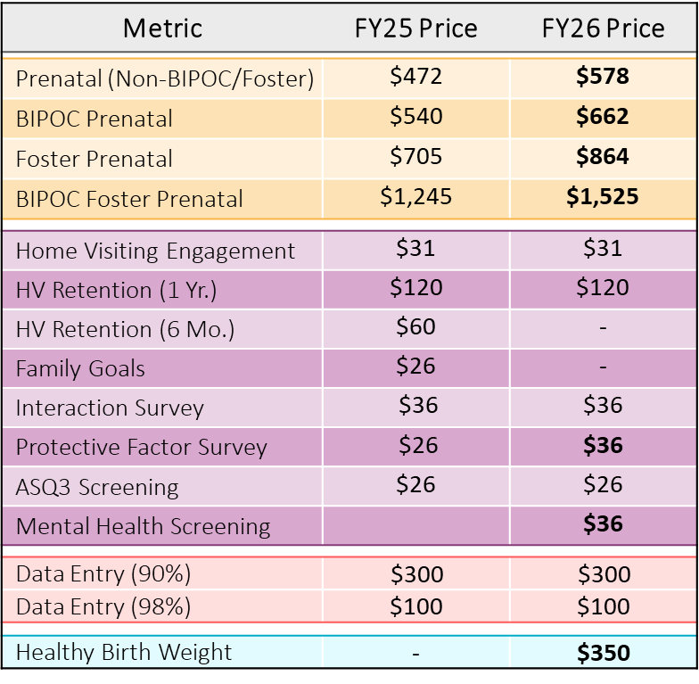

Metrics for 6-month family retention and family goals were removed because achievement was high, and we wanted to introduce new priority metrics without overburdening participants. New metrics included maternal depression screening and healthy birth weight. We increased pricing for most of the metrics to right-size projected achievement to the annual incentive budget ($1 million), while keeping prenatal enrollment as the top priority in our pricing model (~50% of annual incentive budget). To ensure the integrity of project data for the sake of both the ORC and our statewide home visiting evaluation, we retained bonus payments for achievement of complete and valid data and provided participants with quarterly data-quality reports to support improvement between designated time points.

We supported performance improvement through quarterly provider meetings in which we reviewed quarterly achievements and trends, discussed implementation questions, and provided training. Training focused on how prenatal visit compliance improves maternal-child outcomes, the American College of Obstetricians & Gynecologists (“ACOG”) schedule of prenatal visit recommendations, and collection of the family’s Department Client Number (“DCN”) used to link home visiting data to Medicaid claims data as part of our statewide home visiting evaluation.

Prenatal enrollment in home visiting has steadily increased through the project since it launched in 2023, with 552 total prenatal enrollments between Jan 2023 – Dec 2023 and 902 prenatal enrollments between Jan 2025 – Dec 2025. During the reporting period, 1,375 families were prenatally enrolled in home visiting by programs participating in the ORC.

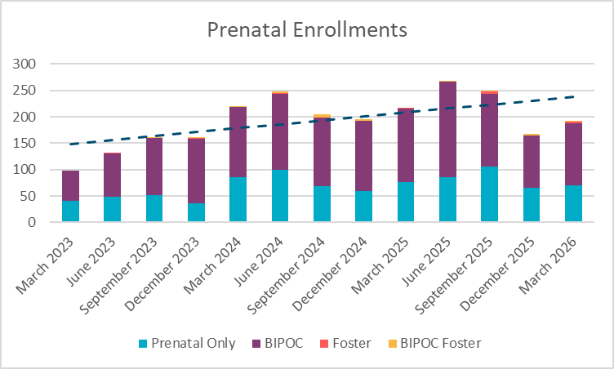

Achievement of the new healthy birth weight outcome was low, given the high threshold for achievement (child born during reporting period at >=5 lbs. 8 oz.; mother enrolled in home visiting at <=28 weeks gestation; mother enrolled in, or eligible for, Medicaid; AND mother attended >=50% of ACOG recommended prenatal visits between enrollment and birth) and many factors being out of participants’ control. That said, this metric is acclimating programs to looking at priority outcomes in addition to process measures, and we expect to see improvement in this outcome over time as programs become more comfortable and skilled in facilitating families’ access to, and compliance with, prenatal care.
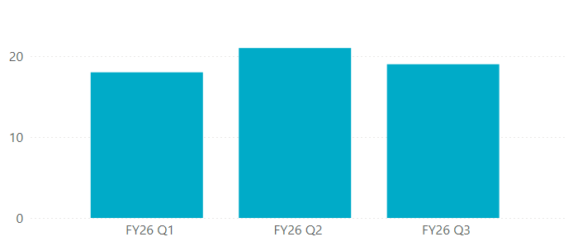
FY26 Healthy Birth Weight Outcomes by Quarter
We elected to continue the same metrics and pricing in the upcoming, final year of this project to continue building momentum around the metrics introduced in FY26 and to optimize data collection for the statewide home visiting evaluation. We will also be transitioning aspects of ORC project management that our consultants have been managing to the CTF team, as our staff capacity has grown and our goal is to manage the next cycle of this project independently. We will continue to work with our project consultants at Social Finance on planning for a new cycle of the ORC.

